Dalton C. Brown

Olapido A. Jegede

Kali J. Nelson

Zachariah D. Pramschufer

FAMU-FSU College of Engineering  2525 Pottsdamer St. Tallahassee, FL. 32310

Team 33: Convertible High Heel Shoe Project Scope

#### 10/5/2017

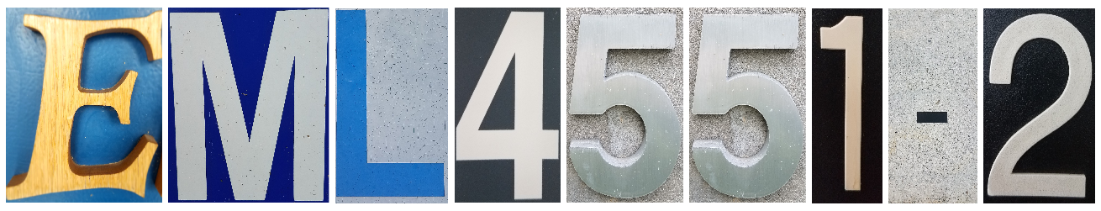

#### 

#### Table of Contents

Project Description iii

Key Goals iii

Primary Market iii

Secondary Market iii

Assumptions iii

Stake Holders iv

# Project Description

A convertible shoe with variable height control.

# Key Goals

The project has two primary goals: Fashionable. Practical.

Design a shoe that can transition between high heels and relatively flat shoes. The shoe will reduce the strain put on feet by high heels and be more affordable than similar products currently on the market while not sacrificing style. By the end of the InNOLEvation Challenge, the team plans to have a prototype of the Convertible Shoes.

# Primary Market

The primary market for the convertible shoes will be women. These include women in professional and personal environments from ages 15 - 45. These women want to appear stylish in a variety of settings but also have the option to switch to a more comfortable mode of footwear. Convertible shoes will allow wearers to alleviate their discomfort without having to carry multiple pairs of shoes.

# Secondary Market

The secondary market for the convertible shoes will be people who wear shoes with heels. These include but are not limited to: professionals, performers, people with orthopedic conditions, fasionistas, and event-goers. Many of these parties are expected to be on their feet for long periods of time. While high heel shoes are professionally appropriate in conjunction with being fashionable they are not comfortable.

# Assumptions

Prototype will be assumed to be hand built. 3-D printing is assumed to be used in creation of parts.

# Stake Holders

This project is an entrepreneurial project. Thus, there is not a large company with a stake in the team’s design. The primary stakeholders are the four members of the team working on the project: Dalton C. Brown, Olapido A. Jegede, Kali J. Nelson, Zachariah D. Pramschufer. The sponsors for the project, FSU-FAMU College of Engineering and faculty member Dr. Devine, and the instructor of the senior design class, Dr. Shayne McConomy, have a stake in the project and its outcome as well.